Worksheet 1.2

Student Name: Ayush Yadav UID: 25IMC13004
Branch: MCA (AI & ML) Section/Group: MAM-1 (A)
Semester: II Date of Performance: 30/01/26
Subject Name: Generative AI Lab Subject Code: 25CAP-674

- Aim/Overview of the practical:

Implement a sentimental analysis system using Hugging Face’s BERT model

Coding:
from transformers import AutoModelForSequenceClassification, AutoTokenizer
import torch

model_name = "nlptown/bert-base-multilingual-uncased-sentiment"
tokenizer = AutoTokenizer.from_pretrained(model_name)
model = AutoModelForSequenceClassification.from_pretrained(model_name)

text = "We should not go out to play today"

inputs = tokenizer(
text,
return_tensors="pt",
padding=True,
truncation=True
)

with torch.no_grad():
logits = model(**inputs).logits

probabilities = torch.nn.functional.softmax(logits, dim=-1)

prediction = torch.argmax(probabilities, dim=1).item()

sentiment = "Positive" if prediction > 2 else "Negative"
print("Probabilities:", probabilities)
print("Predicted label index:", prediction)
print("Sentiment:", sentiment)

OUTPUT:

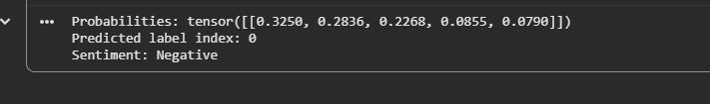

3. Learning outcomes (What I have learnt):
• Understand the fundamentals of Natural Language Processing (NLP) and sentiment analysis techniques.
• Load and utilize Hugging Face’s pre-trained BERT model for sentiment classification tasks.
• Preprocess and tokenize textual data appropriately for transformer-based models.
• Perform sentiment prediction on input text using BERT and interpret the output probabilities.
• Evaluate sentiment analysis results for accuracy, confidence, and real-world applicability.

